**PROJECT 3 DESIGN NOTEBOOK**

**TEAM 45**

**KATHRYN ATHERTON**

**JOSHUA HAHN**

**HANNAH MACKIN SCHENCK**

**TABLE OF CONTENTS**

|  |  |
| --- | --- |
| Meeting Agendas and Minutes | 2 |
| Project Scheduling, Management | 6 |
| Gantt Chart | 6 |
| Project Management | 6 |
| Work Breakdown Structure | 7 |
| Brainstorming | 8 |
| Morphological Chart | 8 |
| Prototypes | 9 |
| Prototype I | 9 |
| Prototype II | 10 |
| Flowcharts and QFDs | 11 |
| Experiments and Results | 12 |
| Decision Matrices | 13 |
| House of Quality | 13 |

**MEETING AGENDAS AND MINUTES**

January 31, 2016, 6pm

Agenda:

* C2 BNS
* Project 3 Gantt Chart

Meeting Minutes:

* Team worked on C2 Bonus Activities
* Discussed a basic meeting schedule for Project 3

Electronic Signatures:

* Kathryn Atherton
* Joshua Hahn
* Hannah Mackin Schenck

February 2, 2016, 8pm

Agenda:

* Kit Counting

Meeting Minutes:

* Team counted the parts of the kit and recorded the results
* Team submitted the part count

Electronic Signatures:

* Kathryn Atherton
* Joshua Hahn
* Hannah Mackin Schenck

February 3, 2016, 7:30pm

Agenda:

* Kit replenishing

Meeting Minutes:

* Joshua Hahn unable to attend -- excused absence
* Team checked into the Kit Replenish Session in the Engineering Classroom
* Team did a spot check of the parts
* Team received parts needed to replenish the kit

Electronic Signatures:

* Kathryn Atherton
* Hannah Mackin Schenck

February 7, 2016, 8pm

Agenda:

* C3 BNS
* Project 3 DSR

Meeting Minutes:

* Team finished C3 BNS and shared all documents
* Team created the DSR
* The 6 tasks were split between the three members, to be completed before the next meeting

Electronic Signatures:

* Kathryn Atherton
* Joshua Hahn
* Hannah Mackin Schenck

February 8, 2016, 8pm

Agenda:

* Review and edit DSR document

Meeting Minutes:

* Team reviewed each other’s work and made edits to wording
* Team submitted document

Electronic Signatures:

* Kathryn Atherton
* Joshua Hahn
* Hannah Mackin Schenck

February 14, 2016, 4:15pm

Agenda:

* RFAI 1
* Brainstorming

Meeting Minutes:

* Team came up with various means to solve the problems posed by each subsystem
* Means were composed into a Morphological chart
* RFAI 1 Questions were composed
* RFAI 1 document was submitted
* Team began building a basic structure for the ALV

Electronic Signatures:

* Kathryn Atherton
* Joshua Hahn
* Hannah Mackin Schenck

February 16, 2016, 8pm

Agenda:

* C4 BNS, Statistics BNS
* Build body of ALV

Minutes:

* Completed C4 BNS
* Built a model of ALV with conveyor belt for boxes to be dropped off with
* Researched robot models with wheels

Electronic Signatures

* Kathryn Atherton
* Joshua Hahn
* Hannah Mackin Schenck

February 23, 2016, 7:30pm

Agenda:

* Finish wheel chain
* work on holding/unloading antenna
* Experiment with RobotC

Minutes:

* Kathryn Atherton absent -- excused
* Added a 3rd wheel on each side
* Added moter on back to power conveyor belt
* Downloaded RobotC
* We have a clicky brick. We need to get that fixed.

Electronic Signatures:

* Joshua Hahn
* Hannah Mackin Schenck

February 27, 2016, 3:30pm

Agenda:

* Continue building antenna holding/unloading mechanism
* Experiment with RobotC
* Determine when to test the magnetic sensors

Minutes:

* Conveyor belt building continued
* RobotC experimentation begun
* 3D Printed “Slide” Considered using CATIA
* House of Quality outline created

Electronic Signatures:

* Kathryn Atherton
* Joshua Hahn

Hannah Mackin Schenck

**PROJECT SCHEDULING/ MANAGEMENT**

Gantt Chart -- Updated 2/15/2016

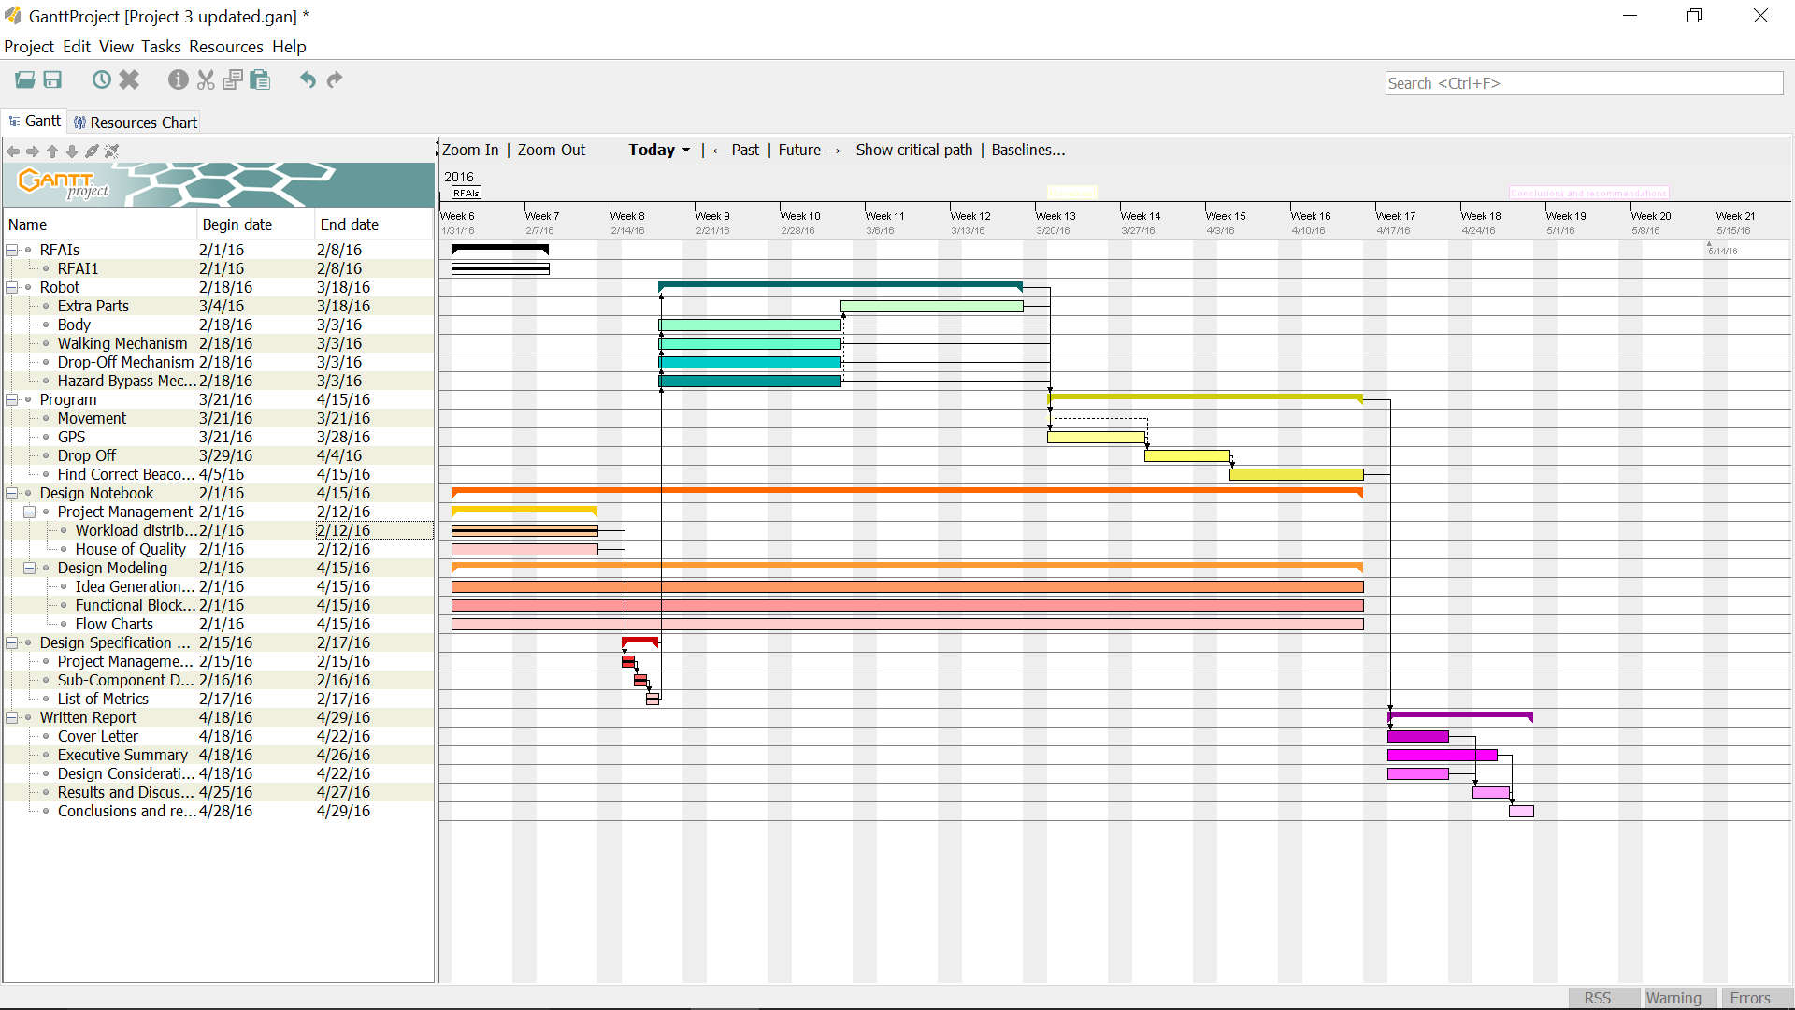

Project Management -- Updated 2/15/2016

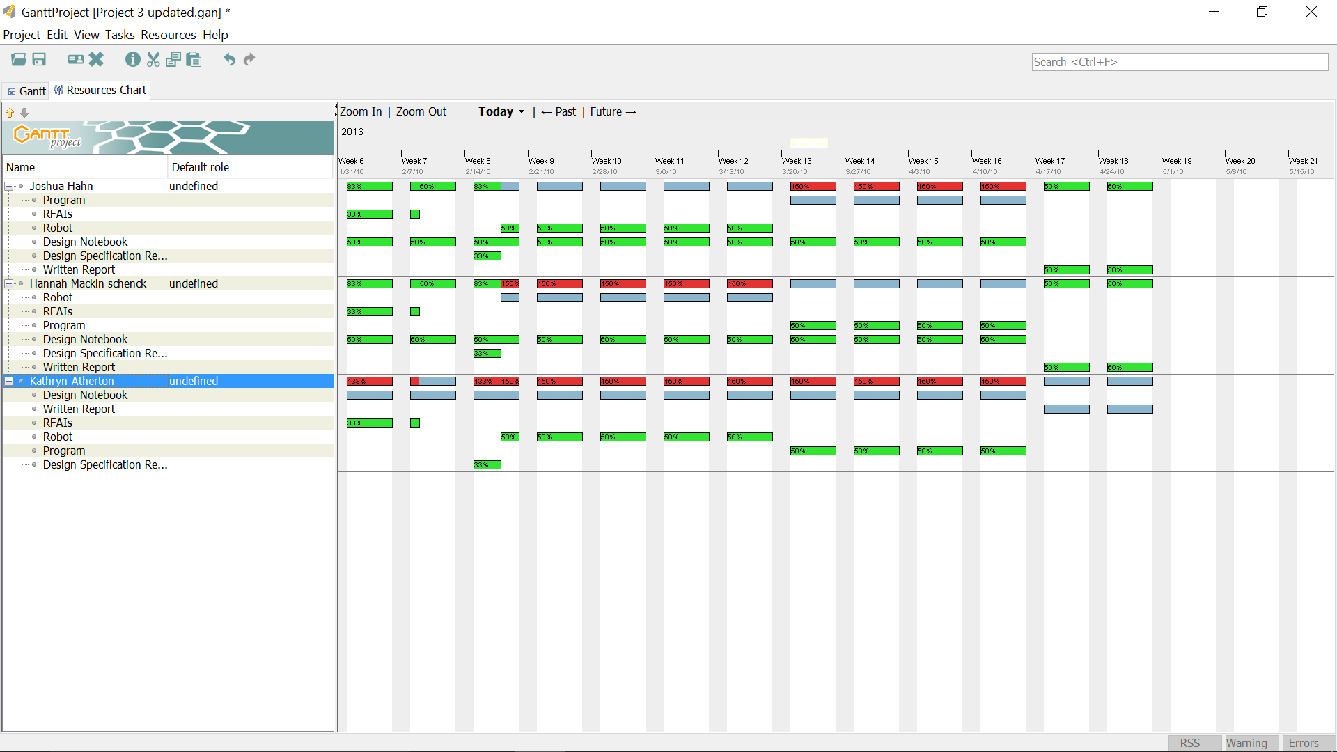

Work Breakdown Structure -- Updated 2/15/2016

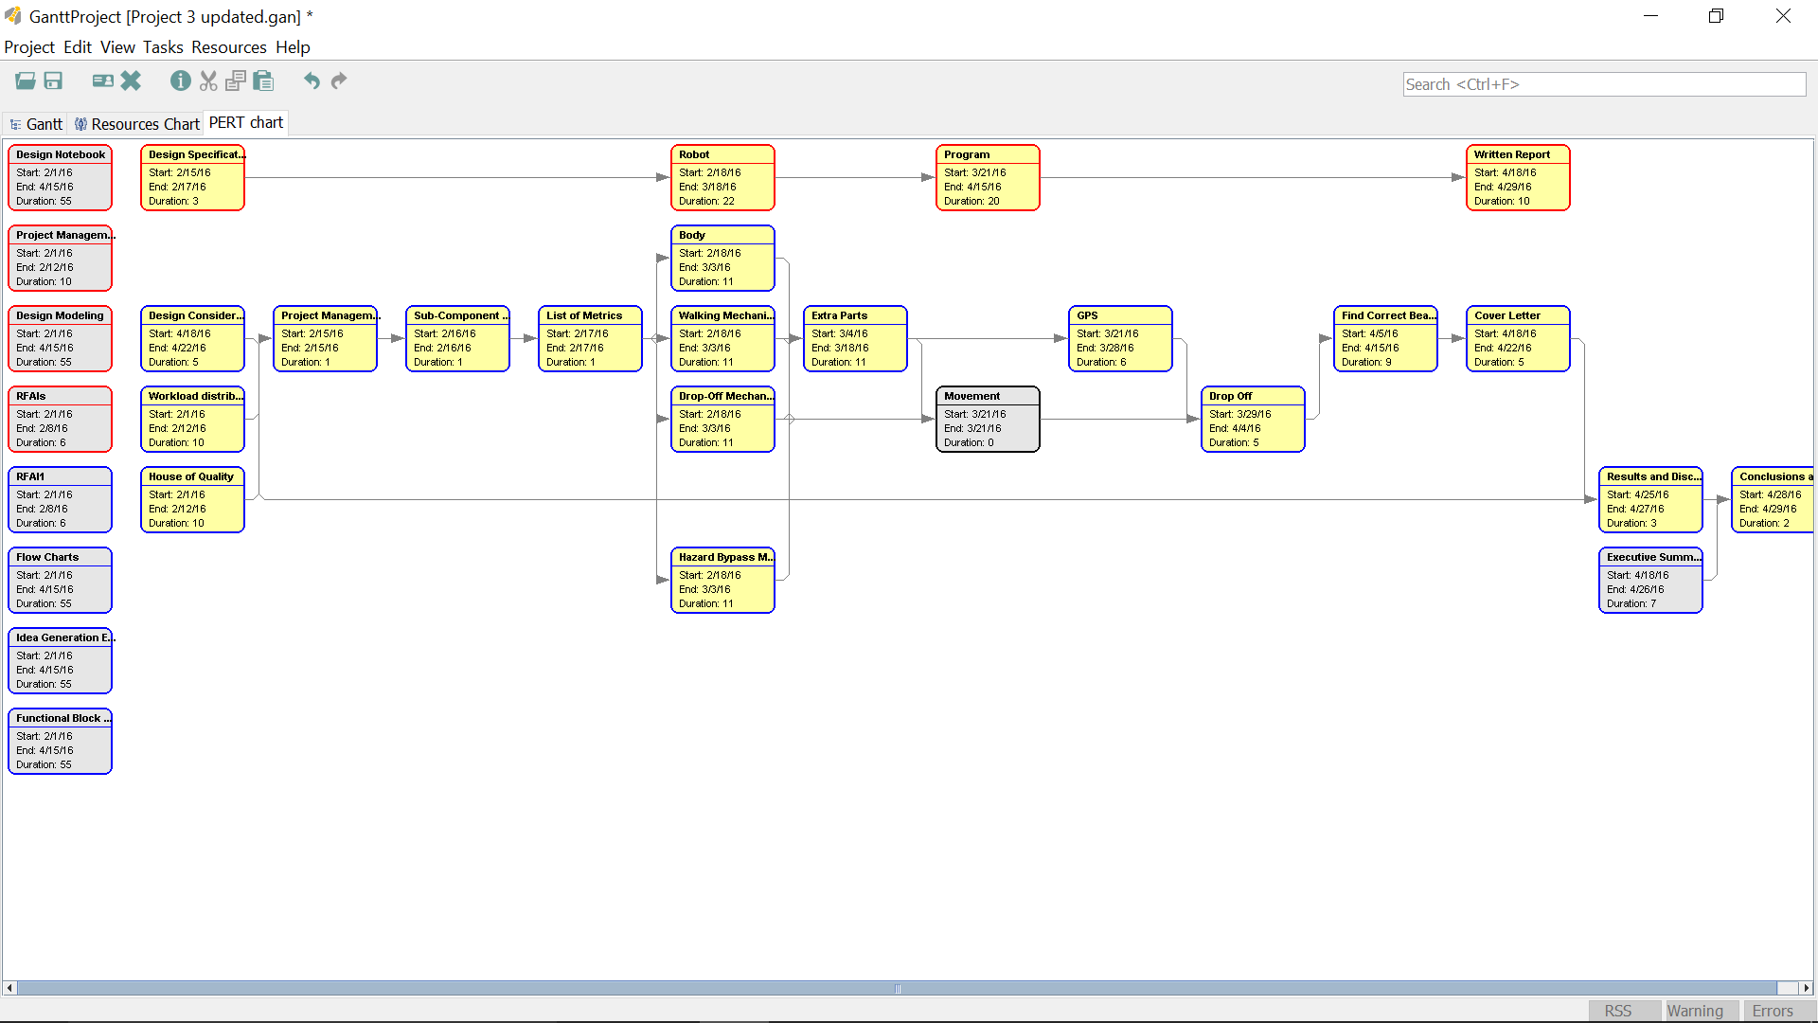

**BRAINSTORMING**

Morphological Chart -- Updated 2/14/2016

|  |  |  |  |
| --- | --- | --- | --- |
| **System** | **Means** | | |
| Body | Tank | Multi-wheel design |  |
| Wheels | treads | big wheels | small wheels |
| Drop-off system | bed with treads | separate container for each antenna |  |
| Drop-off location w/ respect to robot | behind | to the side(s) |  |
| Overcome obstacles | snow plow | drive over |  |

**PROTOTYPES**

PROTOTYPE I -- Created Feb. 16, 2016; Rejected February 16, 2016

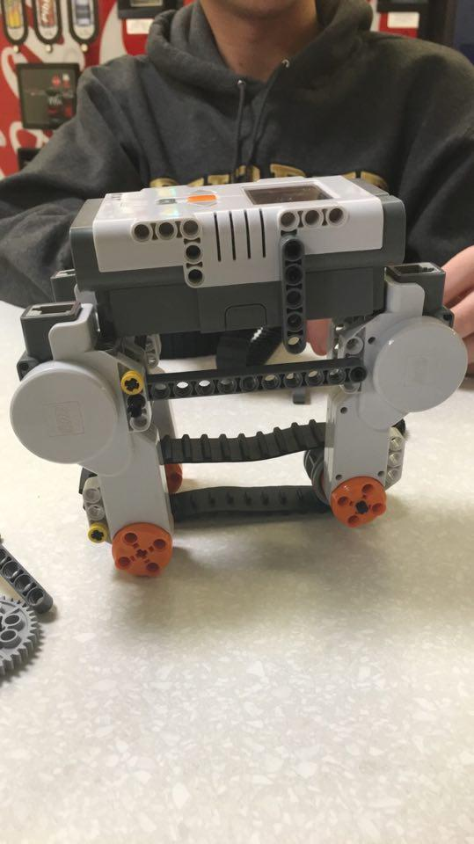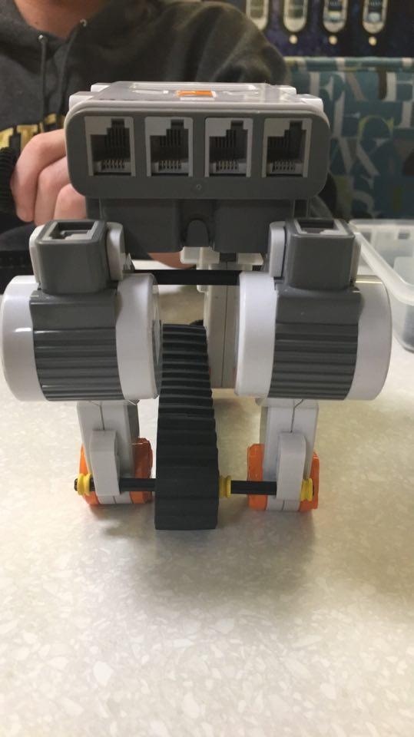

(left side view) (back view)

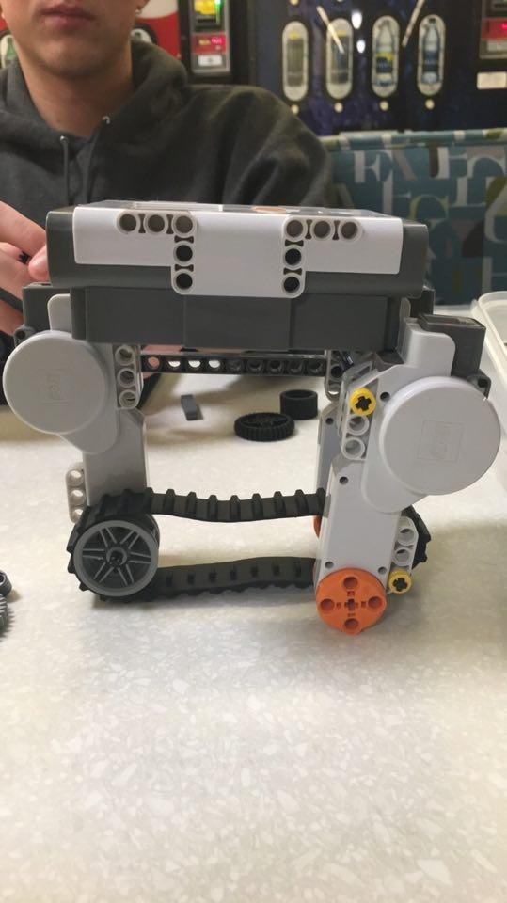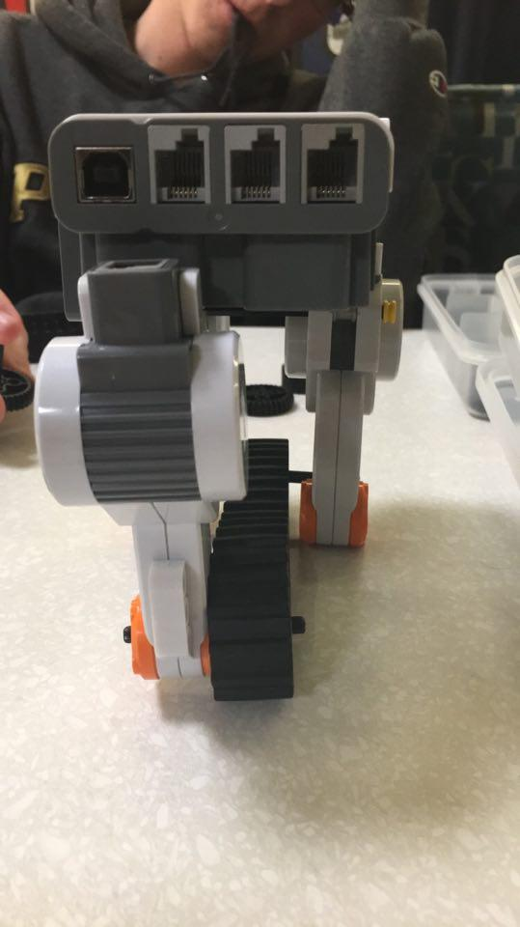

(right side view) (front view)

Explanation of Design:

This design was meant to incorporate the multi-wheel design with small wheels, a conveyor belt-style drop-off system, with the antenna being dropped off behind the ALV. The rationale behind the design was that the boxes would be protected within the body of the robot to prevent them from spilling out or getting damaged during landing and travel. This design was ultimately rejected, as the space above the conveyor belt just barely had enough space for the three antenna boxes, thus making the boxes prone to becoming stuck in the space when it was time to drop one off.

PROTOTYPE II -- Created February 16, 2016; Rejected --

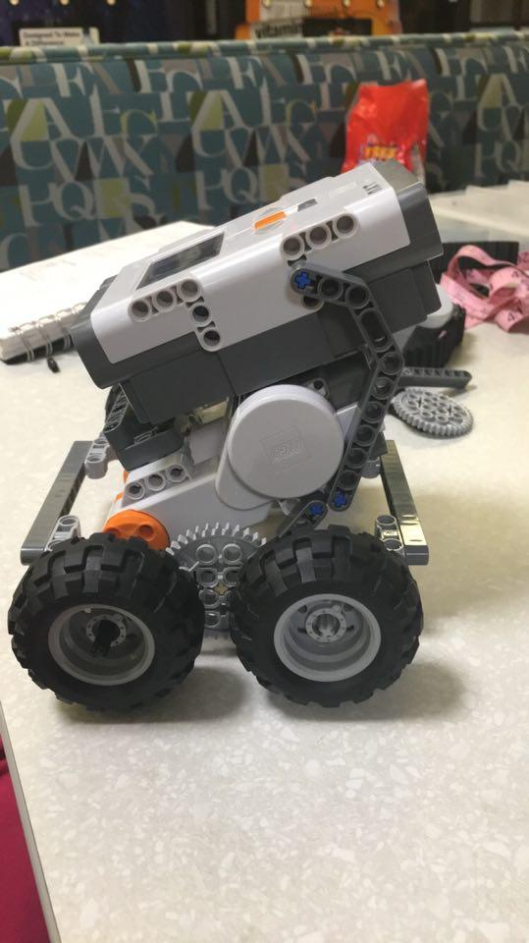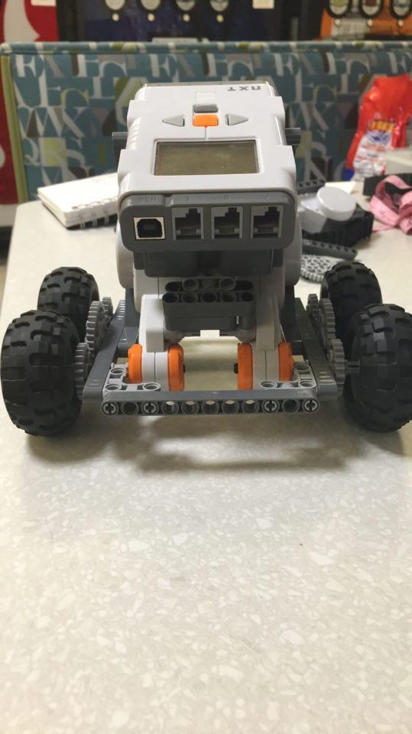

(right side view) (front view)

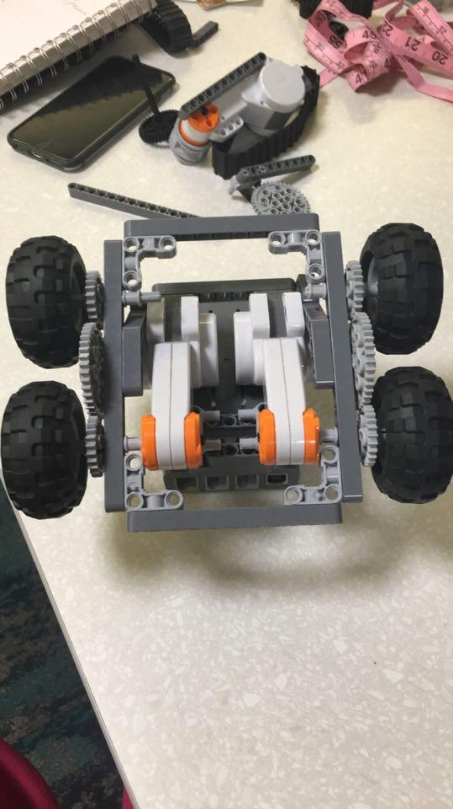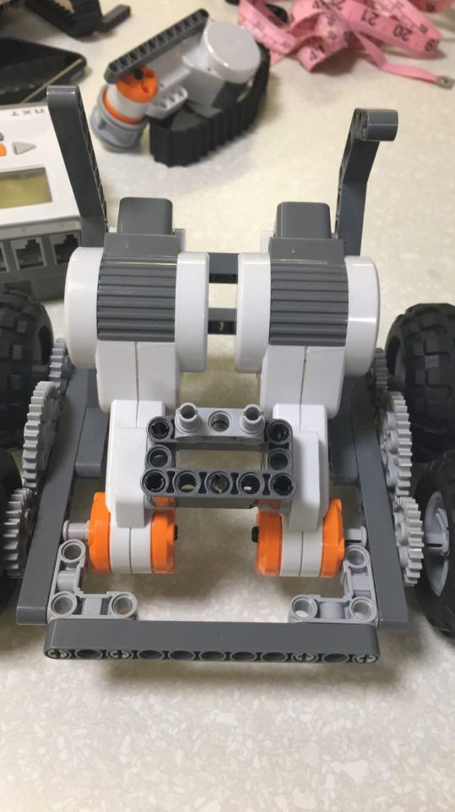

(bottom view) (top view, without brick)

Explanation of Design:

After the first design was rejected, a basic framework for an NXT robot was created based on the research done by the team. February 27, 2016, the team added a conveyor belt to the back in order to hold and drop off the antenna.

**FLOWCHARTS AND QFDs**

**EXPERIMENTS AND RESULTS**

**DECISION MATRICES**

House of Quality -- Updated February 27, 2016

